F. C. I.

Fastpitch Championship Invitational
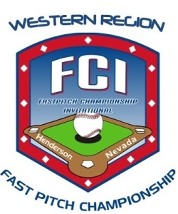
Women's Open National Championship
Henderson/Las Vegas, NV
July 18-21, 2013

www.FastpitchChampionship.com
Format: Prep Play with Double Elimination - Split Morning/Evening Sessions
Venues: Stephanie Lynn Craig Park (Main field), Russell Recreational Park and Arroyo Grande Sports Park.
Fee: $375 non-refundable + mandatory 4 rooms per night per team stay at host hotel.
Check or Credit card accepted.
Host Hotel: Sunset Station - 2.5 miles from fields.
Come enjoy softball at FCI. We are on our way to becoming the premier Women's Tournament in the country. Our unique "split-day" format allows teams to beat the heat. Just minutes from the airport and the world famous Vegas strip. "Staying-In" can be exciting as well. Our host hotel, Sunset Station, has 6 restaurants, a full gaming casino, bowling alley and movie theater on site. SIGN UP NOW to secure your spot!
Contact Tournament Director at : Info@FastpitchChampionship.com

